

GROUP PROJECT

Lecturer : Muhammad Arif Bin Hasan

Group: 13

*Prepared by:*

|  |  |  |
| --- | --- | --- |
| Student ID | Student Name | Phone number |
| 1231302828 | Michelle Theba A/P Jeffrey Paul Raj | 011-1616 0958 |
| 1211203780 | Kuhanraaj A/L Thanasegaran | 011-1079 8199 |
| 1231302919 | Cheng Guo Wei | 011-1093 1369 |
| 1231300995 | Enzo Joaquin Itona Erfe | 010-384 4814 |
|  |  |  |

Declaration by group leader

I hereby declare that all group members’ names are correctly included in the above section. I hold a copy of this assignment which I can produce if the original is lost or damaged. I certify that no part of this assignment has been copied from any other student’s work or from any other source except where due acknowledgement is made in the assignment.

Group leader’s signature : Shape

Group leader’s name : Michelle Theba A/P Jeffrey Paul Raj

Group leader’s student ID : 1231302828

Date : 27/6/2024

Group member declaration

*(Each group member, including the group leader, must individually fill up and submit this form)*

Group member’s name : Michelle Theba A/P Jeffrey Paul Raj

For the purpose of completing this assignment, I have performed the following tasks (please list):

* Wix:
* Designed our e-commerce website called RythmWave using Wix
* Designed pages that includes signup/login page, home page, invoice page, wish list page and account page
* Made a presentation video that covers the signup/login page, home page, invoice page, and account page

*I hereby declare that I have assessed this submission and I take full responsibility should there be any inaccuracies, incompleteness, omissions, delays or non-submission.*

Group member’s signature : Shape

Group member’s name : Michelle Theba A/P Jeffrey Paul Raj

Group member’s ID : 1231302828

Group member’s tel. no. : 011-16160958

Group member’s email : 1231302828@student.mmu.edu.my

Date : 27/6/2024

Group member declaration

*(Each group member, including the group leader, must individually fill up and submit this form)*

Group member’s name : Kuhanraaj A/L Thanasegaran

For the purpose of completing this assignment, I have performed the following tasks (please list):

Wix:

Designed our e-commerce website called RythmWave using Wix

Designed pages that includes:

* Product Page
* Cart Page
* Payment Page
* View order Page
* Order Tracking Page

Made a presentation video that covers the Product Page, Cart Page, Wish list page, Payment page, View order page and order tracking page

*I hereby declare that I have assessed this submission and I take full responsibility should there be any inaccuracies, incompleteness, omissions, delays or non-submission.*

Group member’s signature : 

Group member’s name : Kuhanraaj A/L Thanasgaran

Group member’s ID : 1211203780

Group member’s tel. no. : 01110798199

Group member’s email : 1211203780@student.mmu.edu.my

Date : 28.06.2024

Group member declaration

*(Each group member, including the group leader, must individually fill up and submit this form)*

Group member’s name : Cheng Guo Wei

For the purpose of completing this assignment, I have performed the following tasks (please list):

Figma:

1. Login, register, forgot password page
2. Wishlist page
3. Product preview page
4. Payment checkout page
5. Drop down list when profile icon is clicked on landing page
6. Transaction and invoice page
7. Account setting page
8. Improve cart page

Video presentation:

1. Login, register, forgot password page
2. Drop down list when profile icon is clicked on landing page
3. Transaction and invoice page
4. Account setting page
5. Delivery page

Report for Figma

*I hereby declare that I have assessed this submission and I take full responsibility should there be any inaccuracies, incompleteness, omissions, delays or non-submission.*

Group member’s signature : 

Group member’s name : Cheng Guo Wei

Group member’s ID : 1231302919

Group member’s tel. no. : 011-1093 1369

Group member’s email : 1231302919@student.mmu.edu.my

Date : 27/6/2024

Group member declaration

*(Each group member, including the group leader, must individually fill up and submit this form)*

Group member’s name : ____________________________

For the purpose of completing this assignment, I have performed the following tasks (please list):

*I hereby declare that I have assessed this submission and I take full responsibility should there be any inaccuracies, incompleteness, omissions, delays or non-submission.*

Group member’s signature : ________________________________

Group member’s name : ________________________________

Group member’s ID : ________________________________

Group member’s tel. no. : ________________________________

Group member’s email : ________________________________

Date : ________________________________

Group member declaration

*(Each group member, including the group leader, must individually fill up and submit this form)*

Group member’s name : Enzo Joaquin Itona Erfe

For the purpose of completing this assignment, I have performed the following tasks (please list):

* Designed and created Mobile App User Manual using Canva
* Hosted and managed Github version control for project report and any additional files
* Recorded video section covering the Mobile App User Manual

*I hereby declare that I have assessed this submission and I take full responsibility should there be any inaccuracies, incompleteness, omissions, delays or non-submission.*

Group member’s signature : 

Group member’s name : Enzo Joaquin Itona Erfe

Group member’s ID : 1231300995

Group member’s tel. no. : 010-384 4814

Group member’s email : 1231300995@student.mmu.edu.my

Date : 27/06/2024

LDCW6123 FUNDAMENTALS OF DIGITAL COMPETENCE FOR PROGRAMMERS

**SELF PEER EVALUATION**

**INSTRUCTIONS:**

Assess each member of your group, including yourself, using the form below. Write your group member’s names across the top including your own, and then rate each person in the categories using the number system below. This evaluation is done anonymously. Be honest with yourself and in evaluating others. Submit this evaluation personally to your group leader.

Rating scale: Poor - 1

Below average - 2

Average - 3

Above average - 4

Superior - 5

|  |  |  |  |  |  |
| --- | --- | --- | --- | --- | --- |
| Evaluation Criteria | Member 1 | Member 2 | Member 3 | Member 4 | Member 5 |
| Attend group meetings regularly and arrive on time. |  |  |  |  |  |
| Participate/Contribute meaningfully to group discussion. |  |  |  |  |  |
| Prepare task assigned in a quality manner. |  |  |  |  |  |
| Demonstrate a cooperative and supportive attitude to all team members. |  |  |  |  |  |
| Total: | /20 | /20 | /20 | /20 | /20 |

**Table of contents**

Table of Contents

Description of chosen Project 9

Web-based Prototype (Wix.com) 9

Mobile-based Prototype (Figma) 9

Mobile App User Manual (Canva) 9

Website Details 10

Website Sitemap 10

Website Screenshot 11

Mobile App Details 15

Mobile Apps Screenshot 15

Mobile App User Manual Details 17

User Manual Screenshots 17

Github Usage 20

Assessment Rubric 22

# Description of chosen Project

1. **E-commerce**

The purpose of the website is to sell items online. The features will include:

* Gallery with high-quality images.
* Pages that list the products and add to cart function.
* Wishlist of customers.
* Customers' order invoices.
* Shipping tracking status.

# **Web-based Prototype (Wix.com)**

Website URL Link: <https://michelletheba2307.wixsite.com/rhythmwave>

# **Mobile-based Prototype (Figma)**

Mobile App URL Link: <https://www.figma.com/design/oYwiAzBfuLlNdU0fTJJ8fk/Final-Test?node-id=0-1&t=5dlgaciVskvvvfcP-1>

# **Mobile App User Manual (Canva)**

Mobile App User Manual URL Link: <https://www.canva.com/design/DAGJQHZVThw/oiiahSK2Ez5KKcjIrbb5aQ/view?utm_content=DAGJQHZVThw&utm_campaign=designshare&utm_medium=link&utm_source=editor>

# Website Details

# Website Sitemap

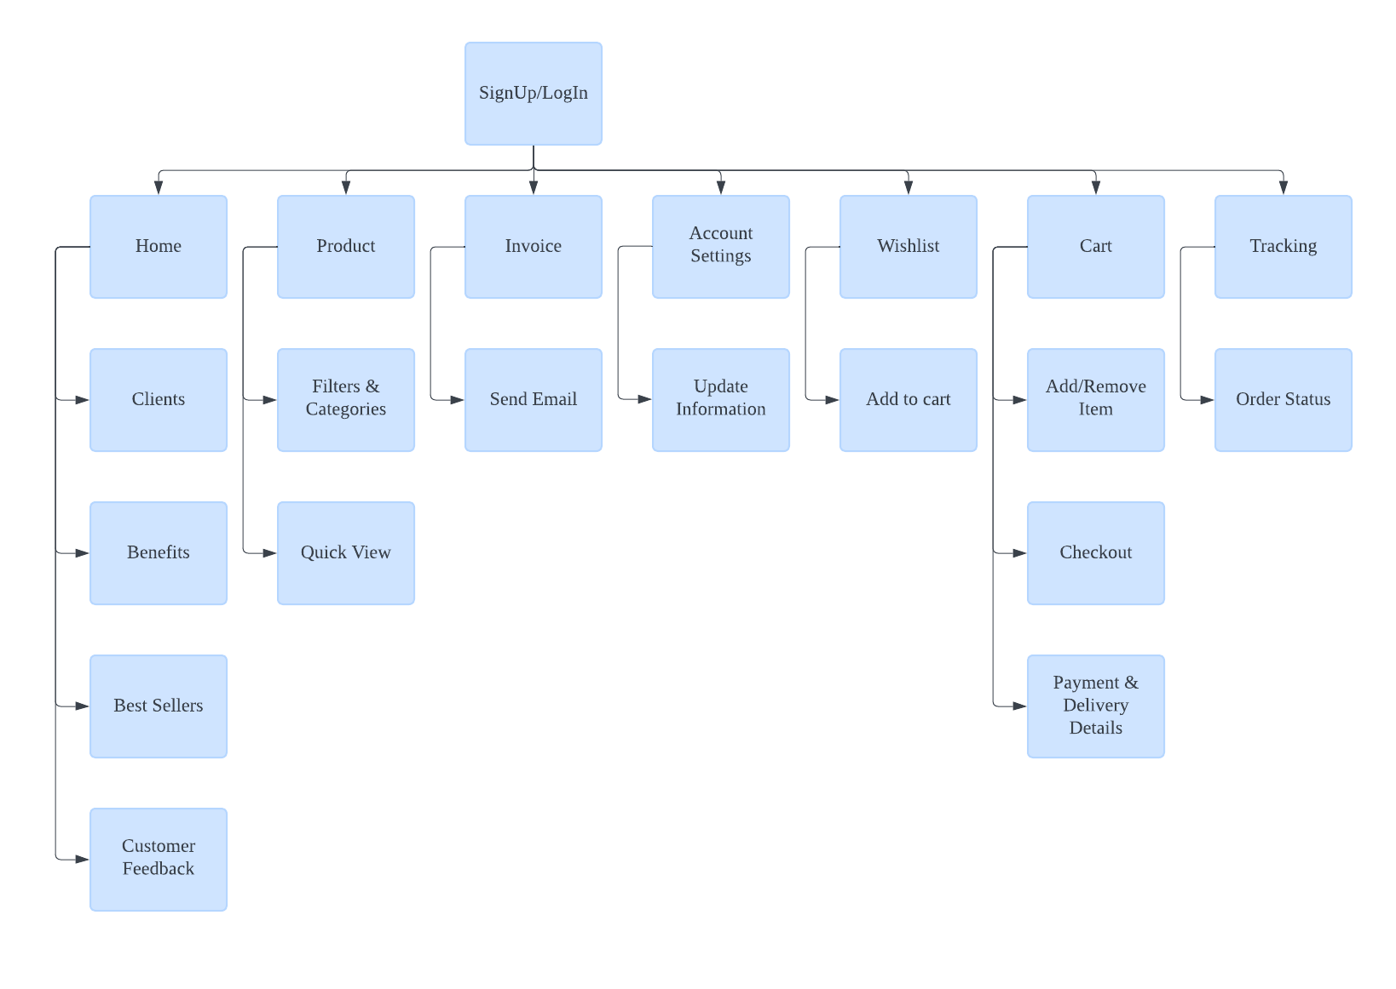*Figure x Website Sitemap*

## Website Screenshot

Below are the screenshots from our website that was developed using Wix.

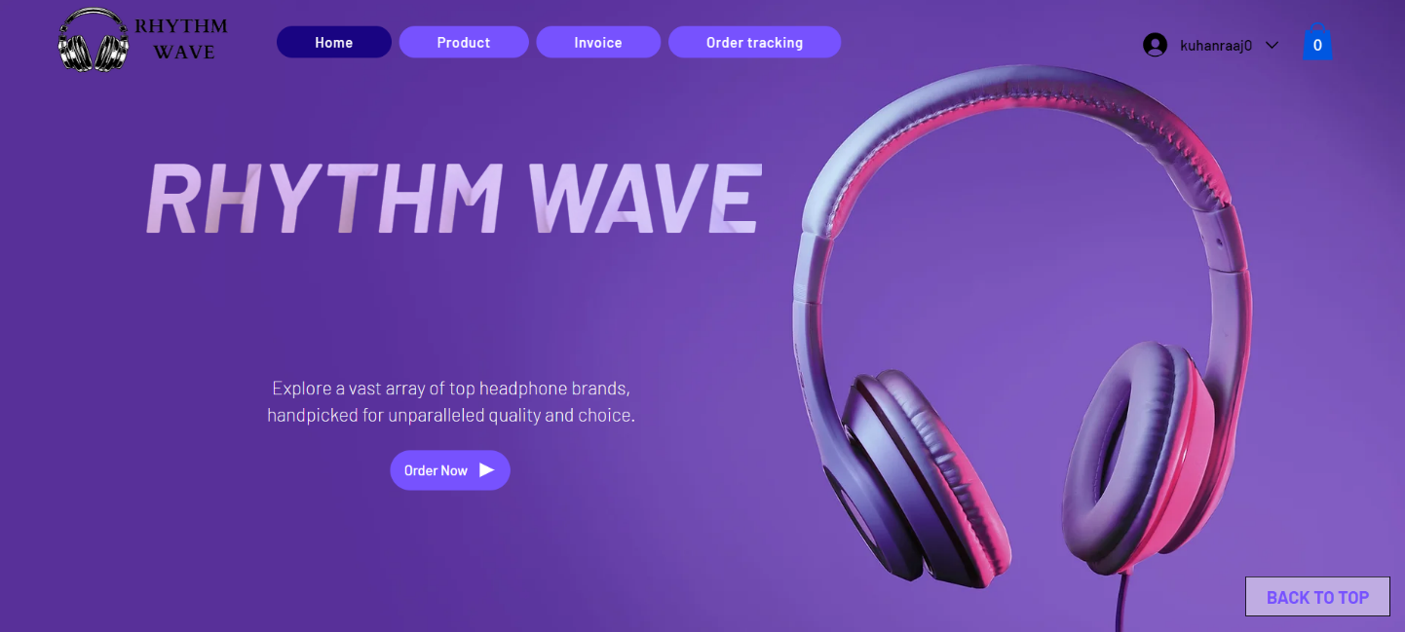

*Figure x Rhythm Wave Home Page*

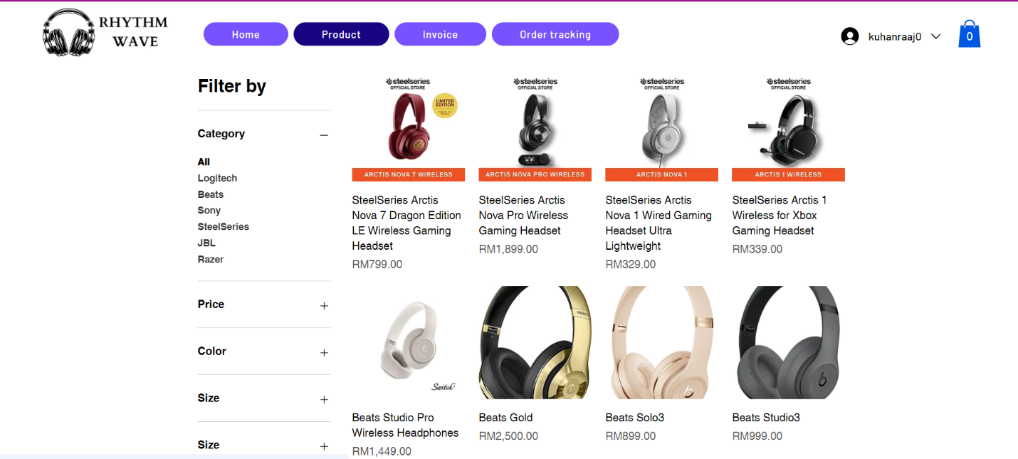

*Figure x Rhythm Wave Product Page*

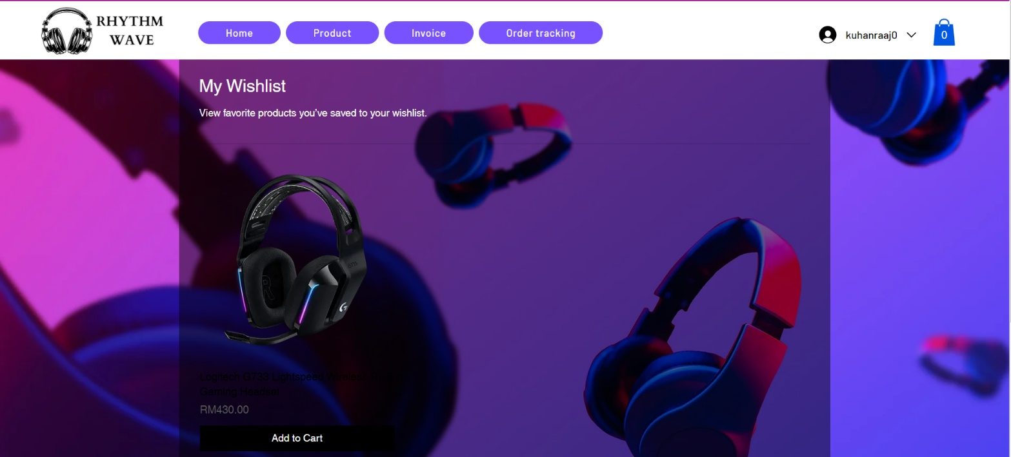*Figure x Rhythm Wave Wishlist Page*

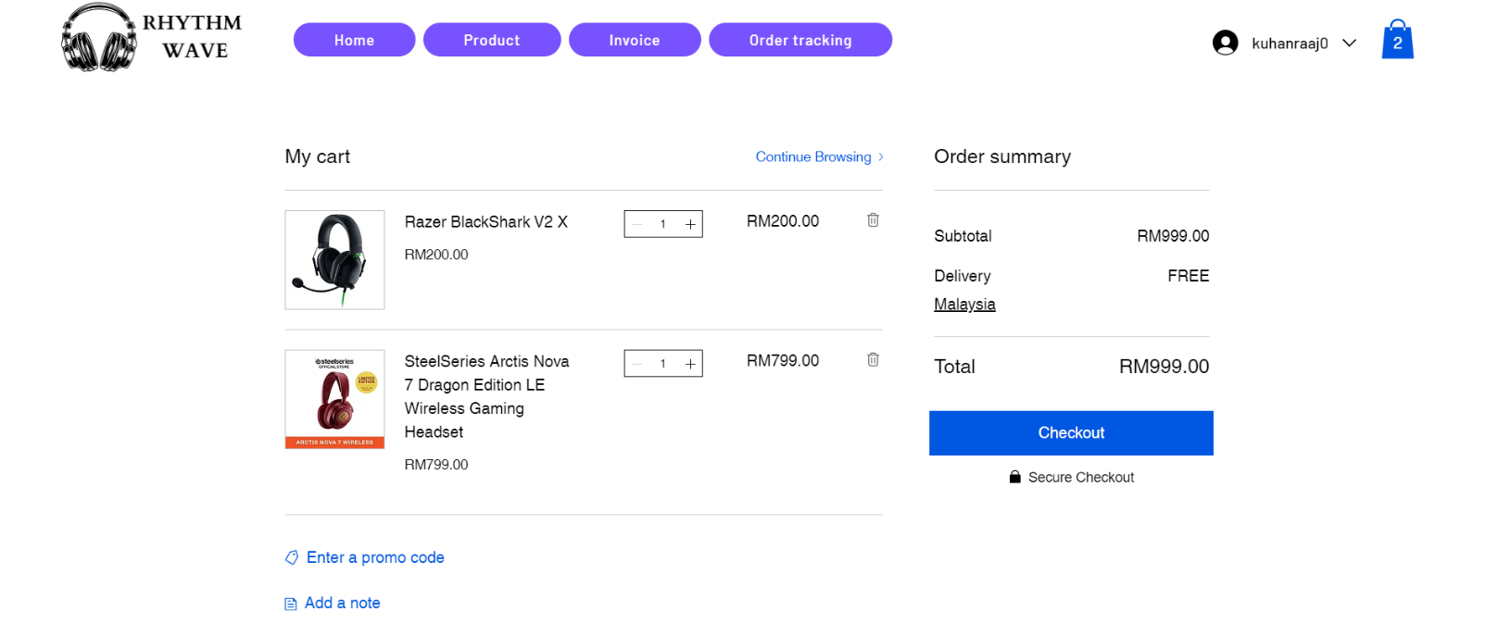*Figure x Rhythm Wave Cart Page*

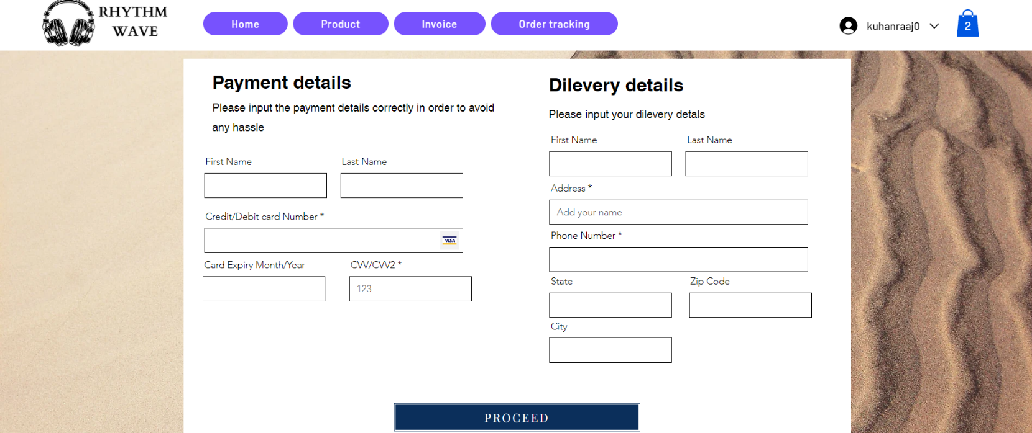*Figure x Rhythm Wave Payment Page*

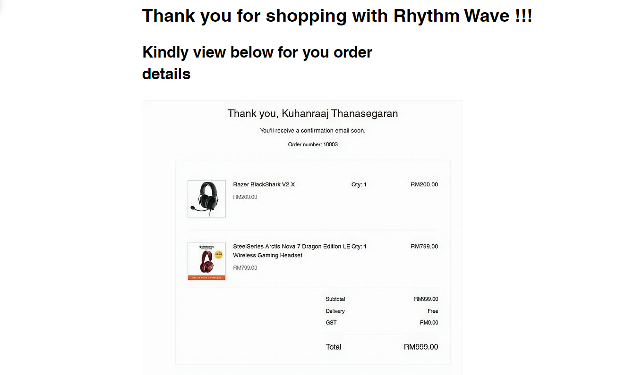*Figure x Rhythm Wave Order Page*

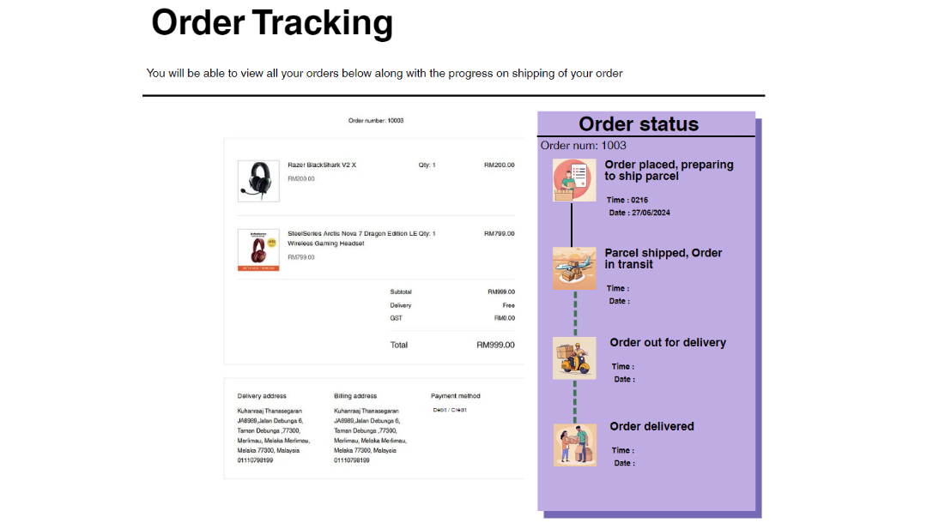*Figure x Rhythm Wave Orde Tracking Page*

# Mobile App Details

## Mobile Apps Screenshot

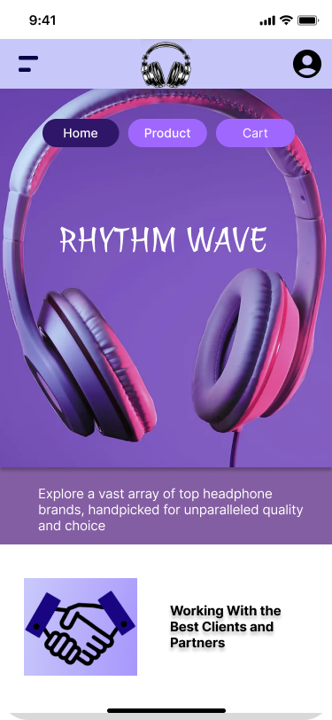

Figure X: Landing page

Figure X:

# Mobile App User Manual Details

## User Manual Screenshots

Figure X: Cover Slide for the Mobile App User Manual

Figure X: Table of Contents for Mobile App User Manual

Figure X: "About Us" Section for providing context

Figure X: "User Dashboard" section to highlight main user interfaces within the Mobile App

Figure X: Sample slide for a "Feature Description"

Figure X: Sample slide of a "Step-by-Step Guide" for the function "Tracking Orders"

# Github Usage

Figure X: Repository Setup

Figure X: Branches and Commits

Figure X: Pull Requests

Figure X: Successfully Merging a branch into main

# Assessment Rubric

**Website & Mobile apps prototype evaluation**

|  |  |  |  |  |  |
| --- | --- | --- | --- | --- | --- |
| **Criteria** | Excellent (5) | Good (4) | Satisfactory (3) | Needs Improvement (2) | Inadequate (1) |
| 1. **User Interface & Design (15 marks)** | | | | | |
| * Visual Appeal |  |  |  |  |  |
| * Navigation and Layout |  |  |  |  |  |
| * Consistency in Design Elements |  |  |  |  |  |
| 1. **Functionality & Interactivity (15 marks)** | | | | | |
| * Responsive Design |  |  |  |  |  |
| * Feature Integration |  |  |  |  |  |
| * Cross-browser Compatibility |  |  |  |  |  |
| 1. **Content Quality (15 marks)** | | | | | |
| * Relevance and Accuracy of Information |  |  |  |  |  |
| * Readability and Clarity |  |  |  |  |  |
| * Multimedia Integration |  |  |  |  |  |
| 1. **Accessibility & Inclusivity (15 marks)** | | | | | |
| * Compliance with Accessibility Standards |  |  |  |  |  |
| * Inclusive Design |  |  |  |  |  |
| * Overall Website & prototype performance |  |  |  |  |  |
| **Total (60 marks)** | | | | | |

**Mobile apps user manual**

|  |  |  |
| --- | --- | --- |
| **Section** | **Marks** | **Evaluation Criteria** |
| Introduction | 5 | * Provide brief overview of purpose and functionality. (3 marks) * Outline target audience for the manual. (2 marks) |
| Dashboard Overview | 5 | * Describe main components of user dashboard. (3 marks) * Provide explanation for each feature and its purpose. (2 marks) |
| Navigation Guide | 5 | * Clearly explain website’s main navigation elements. (5 marks) * Include visuals (screenshots or diagrams) to illustrate key features. (5 marks) |
| Functionality Guides | 10 | * Break down each major feature or service offered on the website. (5 marks) * Provide step-by-step instructions on how to use each function. (5 marks) * Encourage users to explore and make the most of the website’s features. (5 marks) |
| Visual Design and Branding | 5 | * Explain the visual elements of the website, such as colour schemes and logos. (5 marks) |
| **Total** | **(30 marks)** |  |

**Git & Git Hub**

|  |  |  |
| --- | --- | --- |
| **Section** | **Marks** | **Evaluation Criteria** |
| Repository Setup | 2 | * Repository setup with a clear name and README |
| Branching and commits | 3 | * Proper use of branches and clear, descriptive commit messages |
| Collaboration | 3 | * Evidence of collaboration through pull requests and discussion |
| Code quality & Documentation | 2 | * Consistent code formatting and readability. * Clear documentation for setup, usage, and contribution guidelines. |
| **TOTAL** | **(10 marks)** |  |